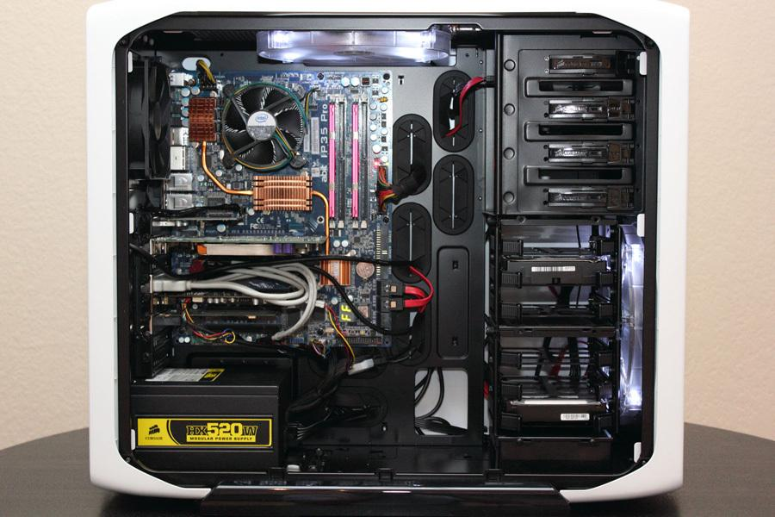

Cooling fan

Motherboard

Hard Disk Drive

Optical Disk Drive

Power supply

USB Expansion Port

Ethernet Port

Audio Port

Monitor Port

3. Research more in-depth about “Motherboards”. Make notes on the following:

a. What different versions are currently available (speed and capacity)

There are many different types of motherboards some being, AT Motherboards, ATX Motherboards. Some motherboards have a bigger CPU socket which makes the pc run faster and smoother. Others have a bigger Ram/Memory which also helps the PC run faster and saves more data than the average PC.

b. How the component has changed since the 1980’s

The Memory boards used to carry 1 Gb Ram which would have been enough for a computer back then, but now days computers need more Ram due to the increase in technology development and software coding’s. The motherboards are twice the size now as they have to hold bigger ports and sockets.

4. Research more in-depth about “Hard Disk Drives”. Make notes on the following:

a. What different versions are currently available (speed and capacity)

Some different versions are, Parallel Advanced Technology Attachment (PATA), Serial ATA (SATA), Small Computer System Interface (SCSI), Solid State Drives (SSD)

b. How the component has changed since the 1980’s

The first hard disk drives created were by IBM which were code named RAMAC. In the 1980’s floppy disks were made as an early version of hard disk drives. Floppy disks were boxes about 24 inches long which you plug into your computer.

**NOTE:**

· Download the on-line version of this module (from the class GitHub repository)

· Questions for Level 2 and Level 3 are in the on-line version of this module

· Provide your answers in a MS Word, PowerPoint, or equivalent format

· Upload your answers to your personal GitHub repository

**Level 2: PC Motherboard**

**Outline**

Learn about the structure of a standard PC motherboard by examining physical samples and selecting and labeling images found on-line. Gain deeper knowledge by researching and reporting on specific components.

**Questions**

1. Find one (or more) images that clearly show the layout of a PC Motherboard.

(i.e. Google images using keywords “PC Motherboard”)

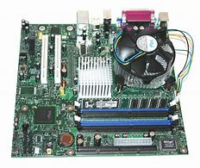

b. RAM Memory

c. Disk Drive Interface (IDE or SATA)

d. GPU Graphics Processor (either on-board or Graphics Card)

e. Sound Processor (either on-board or Sound Card)

f. Wi-Fi / Ethernet Network Interface (either on-board or Graphics Card)

3. Research more in-depth about “CPU Processor Chip”. Make notes on the following:

a. What different versions are currently available (speed and capacity)

There are many different versions but most computers use intel chips. Intel chips are the most popular CPU Processing Chips. The intel core i7 has a speed of 4.7GHz turbo mode and 3.7GHz standard clock speed.

b. How the component has changed since the 1980’s

The first CPU processor chip was extremely slow compared to processor chips not days. It had a clock speed of 108 KHz (and scaled up to 740 KHz).

4. Research more in-depth about “RAM Memory”. Make notes on the following:

|  |  |  |
| --- | --- | --- |
| DDR SDRAM | 184 | 400MHz/3200Mbps |
| DDR2 SDRAM | 240 | 800MHz/6400Mbps |
| DDR3 SDRAM | 240 | 1333MHz/10,600Mbps |
| DDR4 SDRAM* | 288 | 2400MHz/19200Mbps |

a. What different versions are currently available (speed and capacity)

|  |  |  |
| --- | --- | --- |
|  |  |  |

b. How the component has changed since the 1980’s

In the 1980s Ram memory was able to hold about 640 kb. In 1990s about 128 mb. In the 2000s about 4 gbs. In the 2010s about 16 gbs.

**Level 3: Peripheral Devices**

**Outline**

Learn about how peripheral devices are connected to the back side of a typical PC tower case. Examine physical samples, select and labeling images found on-line and gain deeper knowledge by researching and reporting on specific components.

**Questions**

1. Find one (or more) images that clearly show the layout of the back of a typical PC tower case.

(i.e. Google images using keywords “Back Of PC Tower”)

2. Clearly label the following components (using arrows) on your image of the back of a typical PC tower case:

a. Power cord and power switch 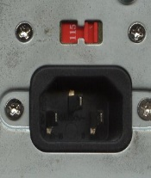

b. Monitor Interface (VGA or DVI or HDMI) 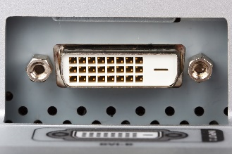

c. Mouse Interface (USB or PS/2) 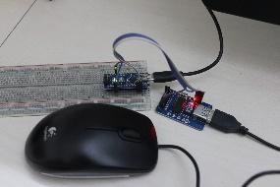

d. Keyboard Interface (USB or PS/2)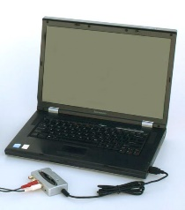

e. USB Ports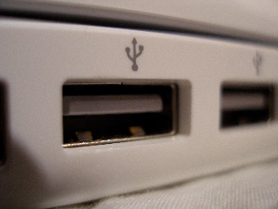

f. Audio Inputs / Outputs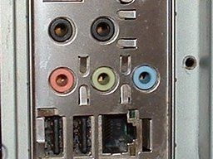

g. Ethernet Interface 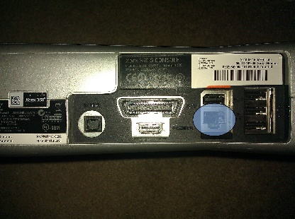

3. Research more in-depth about “Monitor Technology”. Make notes on the following:

a. What different versions are currently available (e.g. VGA / DVI, Flat Panel Technology))

There are three types of Monitors, CRT (Cathode Ray Tube)

LCD (Liquid Crystal Display)

LED (Light-Emitting Diodes)

b. How the component has changed since the 1980’s (e.g. Display Resolution, Technology)

Computer Monitors now days have LED crystal displays as in 1980s, they had a glass screen which was curved and hard.

4. Research more in-depth about “External Portable Storage”. Make notes on the following:

a. Floppy Disks: Early hard disk drives which were a separate box which you connect to your computer.

b. CD-ROM / DVD / Recordable CD/DVD: A CD-ROM can save data and can read it but cannot write or erase it.

c. USB Memory Drives: USB memory drives have a specific amount of gigabits which you can use to store files on. USB drives are portable so you can carry files around with you.

d. Compact Flash Memory: A chip/card which is used in mobile devices to hold storage. Can hold up to 2 MB – 512 GB.

e. Cloud Based Storage: This is where your files can be stored which is not your PC/hard drive. Typically your providers servers.